[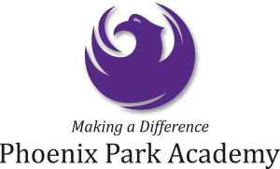](http://www.google.co.uk/url?sa=i&rct=j&q=&esrc=s&source=images&cd=&cad=rja&uact=8&ved=2ahUKEwiXnY7lnsjjAhUAAWMBHQeQDmcQjRx6BAgBEAU&url=/url?sa%3Di%26rct%3Dj%26q%3D%26esrc%3Ds%26source%3Dimages%26cd%3D%26ved%3D2ahUKEwiEv8LjnsjjAhUHAmMBHVGaCIcQjRx6BAgBEAU%26url%3Dhttps://wellspringacademytrust.co.uk/news/careers/ks3-4-teacher/%26psig%3DAOvVaw2JCJ6Ofyk202_lXFGhRHlm%26ust%3D1563875071061935&psig=AOvVaw2JCJ6Ofyk202_lXFGhRHlm&ust=1563875071061935)

Careers is something that is going to be our focus at Phoenix Park Academy and supporting the students in their post 16 lives. We have lots of exciting things happening and are looking forward to keeping you updated on them all! If you would like to know more please contact Mr Williamson or Mr Knight.

**Phoenix Park Careers**

**Monthly Newsletter – September**

**Overview of the morning – Hull Trains**

Callum and I arrived at Hull Train station for a meeting with the HR manager at Hull Trains. We were shown around Hull Trains Head office (located just down the street from the station) and introduced to the variety of different job roles in the company. We spoke with the HR manager about the qualification needed for different careers and the type of work each entailed. For example, we learnt about the role of an On Board Host and a Conductor. After speaking with HR we then met with the manager of the train drivers, who had previously been a train driver. As Callum is interested in this specific career, we were able to have a more in-depth conversation about how to become a train driver; what qualifications are needed, how the interview and admissions process works, typical shift patterns and the job role. Callum particularly enjoyed this and appreciated the opportunity to pose questions to someone with first-hand experience of the job. Before we left it was agreed that a follow up day would be arranged where Callum could meet with a current train driver and ride in a cab.

[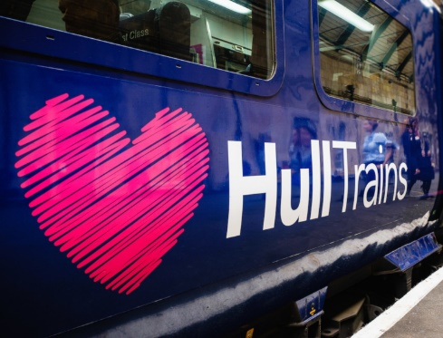](https://www.google.co.uk/url?sa=i&rct=j&q=&esrc=s&source=images&cd=&ved=2ahUKEwiixdXXroDlAhXxxoUKHasLA44QjRx6BAgBEAQ&url=https://www.hulltrains.co.uk/&psig=AOvVaw1uZOt_FzBw3f09-LFh5ARV&ust=1570201533106821)

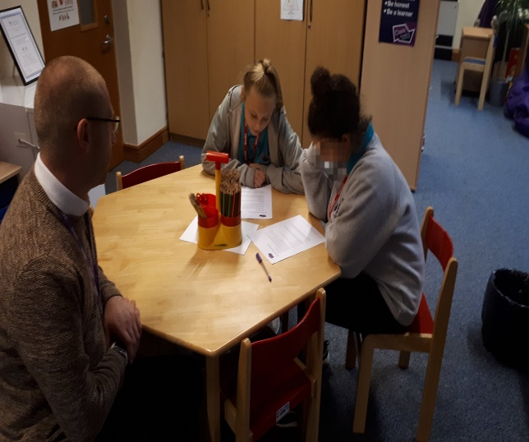

Two students from Parkside have gained the opportunity to develop their own professional skills by working alongside other professionals at Nunsthorpe Academy, in Grimsby. This is a fantastic opportunity for them to immerse themselves in a professional, working environment, as well as seeing education from a different perspective from being a student.  Each individual young person will attend for 1 day per week over the next academic year whilst completing their own portfolio to support their future careers. Mr. Blades (SEMH Teacher) mentioned about embracing new opportunities and never giving up on their future dreams. This is their first step on achieving their chosen careers.